Отчёт студента ПОКС-31B

Практическая №5

Вариант №19

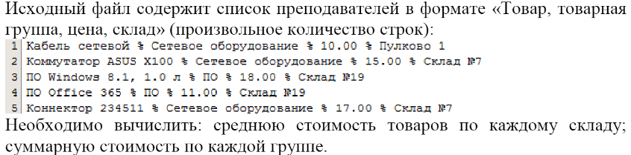

namespace Практическая_5

{

public partial class Form1 : Form

{

private DataStorage data;

public Form1()

{

InitializeComponent();

}

interface DataInterface

{

List<RawDataItem> GetRawData();

List<SummaryDataItem> GetSummaryData();

}

class SummaryDataItem

{

public String GroupName { get; set; }

public float GroupSum { get; set; }

}

class Utils

{

private static Dictionary<float, String> dict;

static Utils()

{

if (dict == null)

{

dict = new Dictionary<float, string>(4);

dict.Add(0, "Товар");

dict.Add(1, "Товарная группа");

dict.Add(2, "Цена");

dict.Add(3, "Склад");

}

}

public static String GetGroupByNumber(float number)

{

if (dict.ContainsKey(number))

return dict[number];

else

return "???";

}

}

class RawDataItem

{

public String Name { get; set; }

public String Group { get; set; }

public float Price { get; set; }

public String Place { get; set; }

}

class DataStorage : DataInterface

{

public bool IsReady

{

get

{

if (rawdata == null) return false;

else return true;

}

}

private List<RawDataItem> rawdata;

private List<SummaryDataItem> sumdata;

private char devider = '%';

private DataStorage() { }

private bool InitData(String datapath)

{

rawdata = new List<RawDataItem>();

try

{

StreamReader sr = new StreamReader(datapath, Encoding.UTF8);

String line;

while ((line = sr.ReadLine()) != null)

{

string[] items = line.Split(devider);

var item = new RawDataItem()

{

Name = items[0].Trim(),

Group = items[1].Trim(),

Price = Convert.ToSingle(items[2].Trim()),

Place = items[3].Trim()

};

rawdata.Add(item);

}

sr.Close();

BuildSummary();

}

catch (IOException ex)

{

return false;

}

return true;

}

private void BuildSummary()

{

Dictionary<float, float> tmp = new Dictionary<float, float>();

sumdata = new List<SummaryDataItem>();

foreach (var item in tmp)

{

sumdata.Add(new SummaryDataItem()

{

GroupName = Utils.GetGroupByNumber(item.Key),

GroupSum = item.Value

});

}

}

public static DataStorage DataCreator(String path)

{

DataStorage d = new DataStorage();

if (d.InitData(path))

return d;

else

return null;

}

public List<RawDataItem> GetRawData()

{

if (this.IsReady)

return rawdata;

else

return null;

}

public List<SummaryDataItem> GetSummaryData()

{

if (this.IsReady)

return sumdata;

else

return null;

}

}

private void ShowData(String datapath)

{

try

{

data = DataStorage.DataCreator(datapath);

}

catch (Exception ex)

{

MessageBox.Show("Что-то сломалось");

}

dgRaw.DataSource = data.GetRawData();

dgRaw.ReadOnly = true;

dgSummary.DataSource = data.GetSummaryData();

dgSummary.ReadOnly = true;

}

private void button1_Click(object sender, EventArgs e)

{

openFileDialog1.InitialDirectory = Application.StartupPath;

if (openFileDialog1.ShowDialog() == DialogResult.OK)

{

ShowData(openFileDialog1.FileName);

}

}

private void button2_Click(object sender, EventArgs e)

{

float a = Convert.ToSingle(dgRaw.Rows[0].Cells[2].Value);

float b = Convert.ToSingle(dgRaw.Rows[1].Cells[2].Value);

float c = Convert.ToSingle(dgRaw.Rows[4].Cells[2].Value);

textBox1.Text = (a+b+c).ToString();

float a1 = Convert.ToSingle(dgRaw.Rows[2].Cells[2].Value);

float b1 = Convert.ToSingle(dgRaw.Rows[3].Cells[2].Value);

textBox2.Text = (a1 + b1).ToString();

float sem = Convert.ToSingle(dgRaw.Rows[1].Cells[2].Value);

float sem2 = Convert.ToSingle(dgRaw.Rows[4].Cells[2].Value);

textBox4.Text = ((sem+sem2)/2).ToString();

float ni = Convert.ToSingle(dgRaw.Rows[2].Cells[2].Value);

float ni2 = Convert.ToSingle(dgRaw.Rows[3].Cells[2].Value);

textBox3.Text = ((ni + ni2)/2).ToString();

textBox5.Text = dgRaw.Rows[0].Cells[2].Value.ToString();

}

}

}

